Rockbuster Stealth LLC
Data Dictionary
Puneet Badwal

Table of Contents:
Entity Relationship Diagram (ERD) …………………………………………..3
Payment Table ………………………………………………………………………4
Rental Table …………………………………………………………………………4
Film Actor Table ……………………………………………………………………4
Inventory Table …………………………………………………………………….4
Film Category Table ………………………………………………………………4
Customer Table …………………………………………………………………….5
Staff Table …………………………………………………………….……………..5
Store Table …………………………………………………………………………..5
Address Table ……………………………………………………………………….6
City Table …………………………………………………………………………….6
Actor Table …………………………………………………………………………..6
Category Table ……………………………………………………………………..6
Film Table ……………………………………………………………………...……6
Language Table …………………………………………………………………….7

Entity Relationship Diagram (ERD)
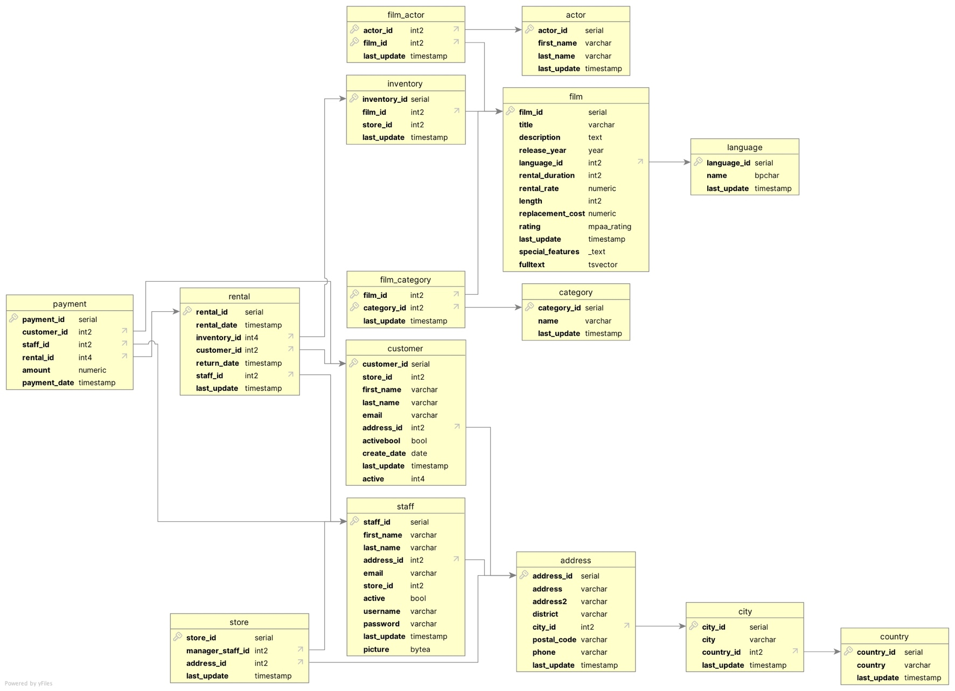

Fact Tables:
Table Name | Column | Data Type | Description
payment | Payment_id (PK) | Serial | Payment id
payment | Customer_id (FK) | Int2 | Cutomer id
payment | Staff_id (FK) | Int2 | Staff id
payment | Rental_id (FK) | Int4 | Rental id
payment | Amount | Numeric | Amount payment
payment | Payment_date | timestamp | Date/time of payment

Table Name | Column | Data Type | Description
rental | Rental_id (PK) | Serial | Rental id
rental | Rental_date | Timestamp | Date/time of rental
rental | Inventory_id (FK) | Int4 | Inventory id
rental | Customer_id (FK) | Int2 | Customer id
rental | Return_date | timestamp | Date/time of return date
rental | Staff_id (FK) | Int2 | Staff id
rental | Last_update | Timestamp | Date/time of last update

Dimension Tables:
Table Name | Column | Data Type | Description
film_actor | Actor_id (Composite PK) | Int2 | Actor id
film_actor | Film_id (Composite PK) | Int2 | Film id
film_actor | Last_update | Timestamp | Date/time of last update

Table Name | Column | Data Type | Description
inventory | Inventory_id (PK) | Serial | Inventory id
inventory | Film_id (FK) | Int2 | Film_id
inventory | Store_id | Int2 | Store id
inventory | Last_update | Timestamp | Date/time of last update

Table Name | Column | Data Type | Description
film_category | Film_id (Composite PK) | Int2 | Film id
film_category | Category_id (Composite PK) | Int2 | Category id
film_category | Last_update | Timestamp | Date/time of last update

Table Name | Column | Data Type | Description
customer | Customer_id (PK) | Serial | Customer id
customer | Store_id | Int2 | Store id
customer | First_name | Varchar | Customer’s first name
customer | Last_name | Varchar | Cutomer’s last name
customer | Email | Varchar | Customer’s email address
customer | Activebool | Bool | Indicates if customer is active
customer | Creat_date | Date | Date of customer account creation
customer | Address_id (FK) | Int2 | Address id
customer | Last_update | Timestamp | Date/time of last update
customer | Active | Int4 | Customer active

Table Name | Column | Data Type | Description
staff | Staff_id (PK) | Serial | Staff id
staff | First_name | Varchar | First name of staff member
staff | Last_name | Varchar | Last name of staff member
staff | Address_id (FK) | Int2 | Address id
staff | Email | Varchar | Staff member email address
staff | Store_id | Int2 | Store id
staff | Active | Bool | Staff member active status
staff | Username | Varchar | Username of staff member
staff | Password | Varchar | Password of staff member
staff | Last_update | Timestamp | Date/time of last update
staff | Picture | Bytea | Staff member photo

Table Name | Column | Data Type | Description
store | Store_id (PK) | Serial | Store id
store | Manager_staff_id (FK) | )Int2 | Manager staff id
store | Address_id (FK) | Int2 | Address id
store | Last_update | Timestamp | Date/time of last update

Table Name | Column | Data Type | Description
address | Address_id (PK) | Serial | Address id
address | Address | Varchar | Street address
address | Address2 | Varchar | Second address
address | District | Varchar | District
address | City_id (FK) | Int2 | City id
address | Postal_code | Varchar | Zipcode
address | Phone | Varchar | Phone n umber
address | Last_update | Timestamp | Date/time of last update

Table Name | Column | Data Type | Description
city | City_id (PK) | Serial | City id
city | City | Varchar | City
city | Country_id (FK) | Int2 | Country id
city | Last_update | Timestamp | Date/time of last update

Table Name | Column | Data Type | Description
actor | Actor_id (PK) | Serial | Actor id
actor | First_name | Varchar | Actor’s first name
actor | Last_name | Varchar | Actor’s last name
actor | Last_update | Timestamp | Date/time of last update

Table Name | Column | Data Type | Description
category | Category_id (PK) | Serial | Category id
category | Name | Varchar | Name of category
category | Last_name | Timestamp | Date/time of last update

Table Name | Column | Data Type | Description
film | Film_id (PK) | Serial | Film id
film | Title | Varchar | Title of film
film | Description | Text | Description of film
film | Release_year | Year | Year of film release
film | Language_id (FK) | Int2 | Language id
film | Rental_rate | Numeric | Cost of rental
film | Length | Int2 | Length of film
film | Replacement_cost | Numeric | Cost of replacement
film | Rating | Mpaa_rating | Movie rating
film | Last_update | Timestamp | Date/time of last update
film | Special_features | text | List of special features included
film | Fulltext | Tsvector | Full text search vector

Table Name | Column | Data Type | Description
language | Language_id (PK) | Serial | Language id
language | Name | Bpchar | Name of language
language | Last_update | Timestamp | Date/time of last update

